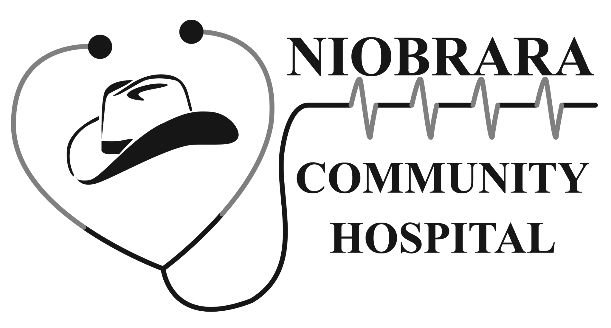  Niobrara Community Hospital  Rawhide Rural Health Clinic  Authorization to release Health Care Information |  |  | Health Information Management  Niobrara Community Hospital/Rawhide Rural Health Clinic  921 S Ballancee Ave Lusk, WY 82225  Fax (307) 334-2712. Phone (307) 334-4000 ext. 255
(1) Patient | Legal Name: |  |  | Preferred/Previous Name(s):
 | Birth Date: |  |  | Phone Number:
 | Address: |  |  | City: State: Zip:
(2) Information  Released  FROM | Niobrara Community Hospital  Other Facility: ________________________________________________________________  Rawhide Rural Health Clinic Address:________________________________________________________________  Phone: __________________________________Fax:___________________________
(3) Dates of service (required) | Dates of Service : FROM:____________________________________ TO: __________________________________
(4)Information disclosed TO | Individual/Facility/Organization OR SELF:
 | Attn/Dept: |  |  |  | Phone Number: |  | Fax:
 | Address: |  |  |  | City: | State: | Zip code:
(5) Health Information to be Released | Abstract Record  (most commonly requested  Check for specialty items  Radiology images (CD)  Billing Information  Other (specify below): | Check if only need individual reports  Provider dictation/notes  MD Notes  ER/Urgent Care Record  History & Physical  Consults  Operative/Procedure reports  Discharge summary  _____________  Other (specify below): |  |  | Check only if need individual reports  Diagnostics  EKG/Tracings  LAB(s)/Pathology reports  Radiology reports  Miscellaneous  Immunizations  Medications  Complete record
(6) Sensitive information | By initialing, I authorize release of the following sensitive information:  ____Alcohol/drug testing ____HIV/AIDS test results or diagnoses  These items will not be released unless initialed.
(7) Purpose of disclosure | ___Personal ___Continuity of care ___Worker’s Comp ___Insurance __Disability  ___ Legal ___Other: ______________________  There may be a charge/fee for copies of records.
(8) Delivery Method | Information to be released on : __ MyPortal (NCHD providers only) ____Paper Information needed by:___________________  Send by: ___FAX ___ MAIL ____ PICK UP by patient or Designee_______________________  ___Email: preferred email address_______________________________ _____Encrypted Staff initial________
(9) Authorization | I hereby authorize Niobrara County Hospital district to release the health information indicated above to the recipient named.  1. I may revoke this authorization at any time in writing, but if I do, it will not have any impact on any actions taken prior to receiving the revocation  2. I understand fee for copy service may apply  3. Your health care (or payment for care) will not be affected by whether or not you sign this authorization.  4. Information disclosed by this authorization may be subject to re-disclosure by the recipient and may no longer be protected by the Health Insurance Portability and Accountability Act Privacy Rule [45 CFR Part 164], and the Privacy Act of 1974 [5 USC 552a].
/
Patient’s/Patient Representative’s Signature Print Name of signee Date
(If signing for a minor patient, I hereby state that my parental rights have not been revoked by a court of law.)
___Parent __POA ___Guardian __other This authorization will expire one year from signature date unless otherwise stated: ____________

